JAVA Oakmont Build Process

[ Formal Release Package & Package+ & Oakmont Patch ]
A. Unzip Formal Release Package
B. Unzip Package+ and overwrite to Formal Release Package
C. Unzip Oakmont Patch [with porting layer + Aplix Lib] and overwrite to step 2 folder
The Oakmont folder is at : \proj\sc\application\3rd\java\Oakmont
The lib part is at : \proj\sc\application\3rd\java\Oakmont\lib
target folder : for target lib
win32 folder : for Simulator lib

[ Target Build Oakmont solution ]
A. Enable Oakmont solution
Get product MAK : \proj\mak\, Find the keyword : JAVA_SOLUTION.
For JTWI solution (Basic Oakmont Solution), you need to fill different solution option : JAVA_SOLUTION = __JAVA_OAKMONT__
For JAP_0 solution (Small Oakmont Solution), you need to fill different solution option : JAVA_SOLUTION = __JAVA_OAKMONT_JAP0__
For JAP_2 solution (Advanced Oakmont Solution), you need to fill different solution option : JAVA_SOLUTION = __JAVA_OAKMONT_JAP2__
B. Build it with command
1. configuration
./tng/configure.pl - Choose product and full build
2. Start to build the project
make release_speed
C. Java Oakmont build command
make clean_lib TARGET=Oakmont
./release_pmake.sh Oakmont to build Oakmont.lib
make release_final to link the target code

[ Simulator Build Oakmont solution ]
A. Open simulator solution
open MMI_BuildAll_cus.sln at proj\MStarStudio_UP\MStarDeveloper\XMMI
B. Add Oakmont project to the solution
Check Simulator product to see if Java_Oakmont project is in the solution.
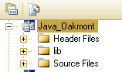
If NOT, add JAVA_OAKMONT project into solution at proj\MStarStudio_UP\MStarKernel\Task\Oakmont
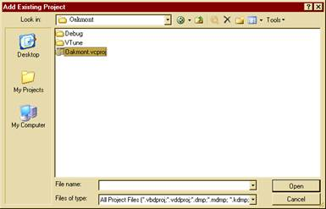
C. Build it
1. Start debug -> if it asks for program to debug, please choose MstarSimulator.exe for executing it. It’s at SRC\proj\MStarStudio_UP\MStarDeveloper\XMMI\debug
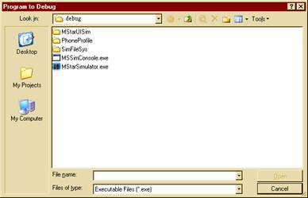
2. After that, need to choose CUS file for loading Language pack.
